CREATE A CHATBOT

**DEFINITION:**

Rule based chat bot follow a set of predefined rules to determine the correct response to user’s input. Self learning chat bot uses machine learning algorithms to understand and respond to user input. Self learning chat bot can be further divided into Retrieval based and Generative based chat bot.

In this sense ,it is presented an inceptive theoretical framework through a formal way for chat bot that can be used as a reference chat bot that can be used as to reference explore, compose, build and discuss with chat bot.

**Dataset Link: [https://www.kaggle.com/datasets/grafstor/simple-dialogs-for-chatbot](https://www.kaggle.com/datasets/grafstor/simple-dialogs-for-chatbot" \t "_blank)**

CODE:

import pandas as pd

import numpy as np

import string

from string import digits

import matplotlib.pyplot as plt

import seaborn as sns

import re

from sklearn.model\_selection import train\_test\_split

import tensorflow as tf

from keras.layers import Input, LSTM, Embedding, Dense, Bidirectional, Concatenate, Dot, Activation, TimeDistributed

from keras.models import Model

from keras.utils import plot\_model

def data\_stats(lines, input\_tok\_split\_fn, target\_tok\_split\_fn):

input\_tokens=set()

for line **in** lines.input:

for tok **in** input\_tok\_split\_fn(line):

if tok **not** **in** input\_tokens:

input\_tokens.add(tok)

target\_tokens=set()

for line **in** lines.target:

for tok **in** target\_tok\_split\_fn(line):

if tok **not** **in** target\_tokens:

target\_tokens.add(tok)

input\_tokens = sorted(list(input\_tokens))

num\_encoder\_tokens = len(input\_tokens)

num\_decoder\_tokens = len(target\_tokens)

max\_encoder\_seq\_length = np.max([len(input\_tok\_split\_fn(l)) for l **in** lines.input])

max\_decoder\_seq\_length = np.max([len(target\_tok\_split\_fn(l)) for l **in** lines.target])

return input\_tokens, target\_tokens, num\_encoder\_tokens, num\_decoder\_tokens,max\_encoder\_seq\_length, max\_decoder\_seq\_length

Linkcode

print('Number of samples:', len(lines))

print('Number of unique input tokens:' , num \_ encoder\_tokens)

print('Numberofuniqueoutputtokens:',num\_decoder\_num\_decoder\_tokens)

print('Max sequence length for inputs:', max\_encoder\_seq\_length)

print('Max sequence length for outputs:', max\_decoder\_seq\_length)

SAMPLE INPUT:

* hi, how are you doing?
* i'm fine. how about yourself?
* i'm fine. how about yourself?
* i'm pretty good. thanks for asking.
* where are you going to school? i'm going to pcc.
* how do you like it so far?
* i like it so far. my classes are pretty good right now.
* it doesn't look very nice outside today.
* you're right. i think it's going to rain later.

BUILDING THE CHAT BOT BY INTEGRETING IT INTO A WEB APP USING FLASH:

Step1: Set up your Open AI account. ...

Step 2: Set Up Your Environment. ...

Step 3: Install Required Libraries. ...

Step 4: Create Flask App Structure. ...

Step 5: Create HTML Template: ...

Step 6: Implement Backend Logic: ...

Step 7: Run the Flask App:

SAMPLE OUTPUT:

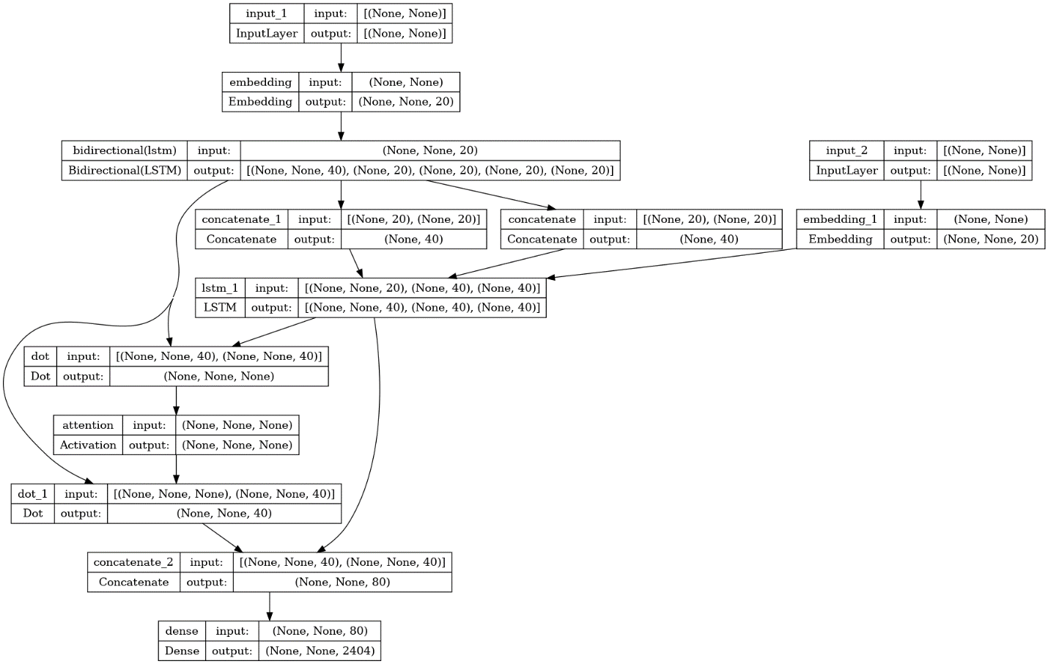

CONCLUSION:

From my perspective, chat bot or smart assistance with artificial intelligence are dramatically changing businesses. There is a wide range of chat bot building platform that are available for various enter prices.

Chat bot can reach out to a Large audience on messaging apps and be more effective than humans.